"It's important to show the machine."  Whoever takes Olafur Eliasson's landscape photographs to be romantic tributes to Iceland is seriously mistaken. "Nature is a product of civilization," the internationally known artist avers. db-art.info had a conversation with Eliasson, whose works are represented in the collection of the Deutsche Bank.  Ohne Titel from the "Islandseries", 1997 Photographie, three parts Ohne Titel from the "Islandseries", 1997 C-print, three parts  "We didn't pass through the countryside, the countryside passed by us, readily assembled, depicted, reproduced, and framed. And all this despite the fact that we were at the very edge of the inhabitable world." Olafur Eliasson (biography) wrote this observation down in the journal he kept on a journey through Iceland in 1997. At first glance, the photograph of the same year from his Iceland Series seems to echo romantic notions of unspoiled nature; the work, which can be seen in this year's art calendar of the Deutsche Bank as well as in the exhibition Fleeting Moments in the bank's Lobby Gallery in New York, shows steam escaping from a geyser in the middle of a barren hill in a broad landscape, mingling with the white of the clouds passing by overhead.  Yet Eliasson's artistic investigations and interventions call precisely this idyllic impression into question. "I don't travel to Iceland to get closer to nature there," Eliasson explains, "I go there to peer out." When viewed for a longer period of time, his landscape photograph starts to resemble a flickering pattern comprised of billions of tiny details emerging from the depth of field. The act of looking "closely" has something arduous about it; after a short time, perceiving the motif absorbs our entire concentration. It almost seems as though we had to assemble the image "anew" in our heads: what parts are vegetation, what parts are gravel? How far away are the clouds from the steam? Where do the clouds of steam behind the hill come from – a pipeline, perhaps? Is that a path there? What are we really seeing?  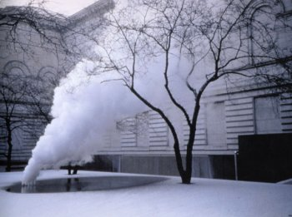  Your natural denudation inverted, 1999  The courtyard of Pittsburgh's Carnegie Museum of Art, winter 1999–2000: warm steam escapes from the icy ground in the museum's inner courtyard, leaving a layer of ice on the tree's branches. In the middle of a large city, the viewer finds himself confronted with an installation recalling the natural phenomenon of the geyser. Yet the work of art is actually founded in technology: In Your natural denudation inverted, Eliasson utilizes one of the building's heating shafts, which he combines with steel scaffolding, a huge water basin, and mechanically generated steam to create an artificial "landscape." Seen through the windows of the museum, the impression of a winter still life or a framed landscape arises. This image evokes associations and feelings similar to those evoked by the "nature" depicted in Eliasson's photograph of Iceland. When he notes that nature is a product of civilization, or that Iceland's lonely landscape has already been "reproduced," what he means is the experience of socialization and civilization that we carry around with us, regardless of what environment we happen to find ourselves in. Our view of nature already changes it the moment we look at it.  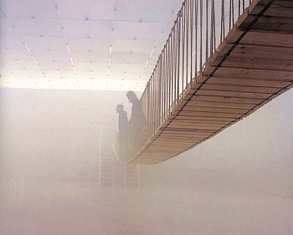  The mediated motion, 2002  Installation, Kunsthaus Bregenz | For some time already, the artist has been investigating whether direct physical experience can transform our idea of the world. He calls his works "devices for locating perception"; they often take on the character of scientific experiments incorporating the viewer. "Every movement includes a degree of mediation – or shall I call it cultivation? Moving in a city or in a landscape also always implies a certain amount of staging and mediation," Eliasson wrote in 2001 on his installation The mediated motion (pictures) in the Austrian Kunsthaus Bregenz. The means he employs with his installations are as elementary as they are transitory: light, heat, damp, steam, and ice. Thus, the interior of the Bregenz museum was translated into a garden-like structure in which each floor and the stairs in between them formed a different platform for viewers to move around on. The exterior is transferred to the interior: the path leads past tree trunks overgrown with mushrooms to a wooden boardwalk spanning a body of water whose surface is covered with duckweed, along an incline of dirty soil, and finally over a hanging bridge in a room filled with smoke.  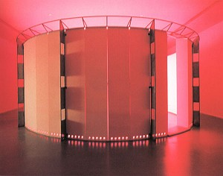  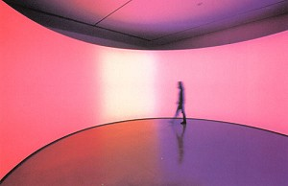  360° room for all colours, 2002  Installation, Musée d'art moderne de la ville de Paris  While Eliasson describes his works as "manufacturing instructions for natural occurrences," comparing them with backdrops and stage techniques, his art also implies the moment of revelation, when we understand how these phenomena have been produced. The insight into the technical and physical processes goes hand in hand with a sense of disillusionment. In an interview recently published in a monographic volume, Eliasson said, "I think the reason why you want to show the machine is to remind people that they're looking," after which he added an analogy: although we can become so caught up in watching a movie that we can think we're somewhere inside the film, we can also "switch over" at any time and realize where we really are. "I think the ability to immerse oneself in a work and then to gain distance again – to show the machine – is important today … my work has a lot to do with the positioning of the subject."  O.K.v.G.  Further links about Olafur Eliasson and his works  Interviews and articles:  An interview with Eliasson about Your natural denudation inverted in the Carnegie Museum of Art, Pittsburgh.  An article by Hjalmar Sveinsson about Eliasson.  An article by Charles Giuliano in retro.rocket.com.  Exhibitions:  Surroundings surrounded/ Graz  Unilever Series/ Tate Modern  Eliasson/ Sao Paulo,  The mediated motion/ Kunsthaus Bregenz (pictures)  Green River series/ Pakkhus/ Dänemark  Green River Series  Arte All'Arte 1999  Your spiral view/ art.net.  © Olafur Eliasson, Berlin  All illustrations have been taken from the monograph "Olafur Eliasson" with the friendly permission of Phaidon Publishers, London/New York 2002.

http://www.db-artmag.com/archiv/06/e/magazin-eliassonartikel.html

